**2021/2022**

# Agile Methods Development

**Assessment 001(100%)**

***Due date:*** *27/01/2022*

**Assessment Brief**

You will analyze an Agile approach to system development by making a detailed investigation of a substantial case study. You need to work as a team (3 – 4 team members) and as such group contribution will be assessed. You will also be assessed on your ability to perform certain aspects of the role of Software Engineering professionals in such settings.

**Learning Outcomes Assessed:**

**LO1**: Classify the advantages and limitations of an Agile approach and apply it as appropriate.

**LO2**: Perform a feasibility and business study, including quantitative estimates of volumes, timing and risk.

**LO3**: Interpret a number of roles within Agile methodologies and participate in a facilitated workshop.

**LO4**: Prepare a critical and reflective analysis on the standards and techniques of team members and provide constructive feedback.

**LO5**: Designs, implements, tests, and debugs software to meet requirements using contemporary methods including agile development.

**Description of the Assessment:**

Create a web application in which the user will log in with a username and password. This application will have the following features:

1. It will contain a list of photos of friends with friends’ name.
2. Clicking on a photo will enter a page with the details of the person depicted (name, surname, age, interests, gender, email)
3. Apart from the photos of your friends, there must be your own profile (with your photo and your personal details).

Ιt will also be possible to log out of the application

**Portofolio exercises**

**Portfolio exercise 1 (due: week 6):**

1. Classify the advantages and limitations of Agile approach among other approaches.
2. Analysis of team roles
3. Application design and requirements

**Portfolio exercise 2 (due: week 13):**

1. Implementation schedule
2. Division of tasks
3. Application implementation

**Indicative answer:**

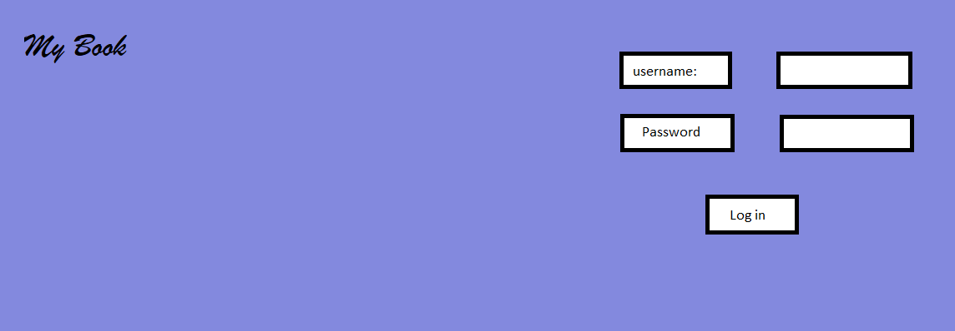

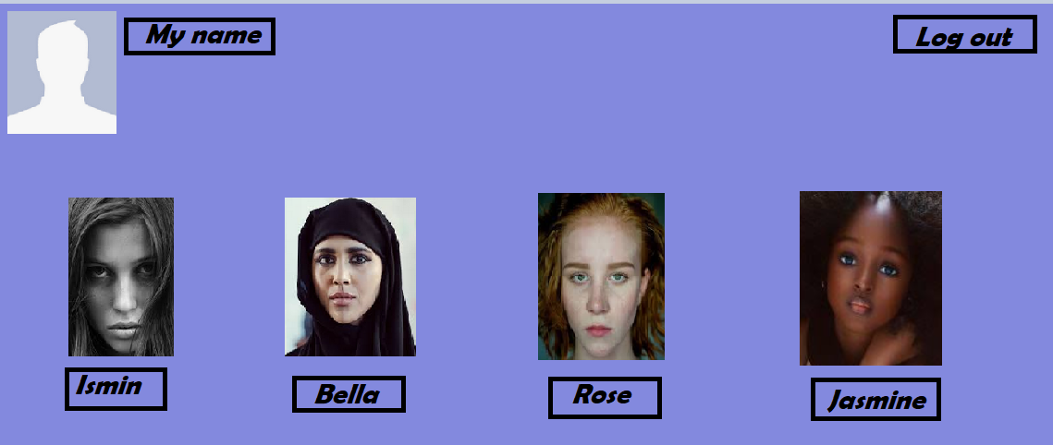

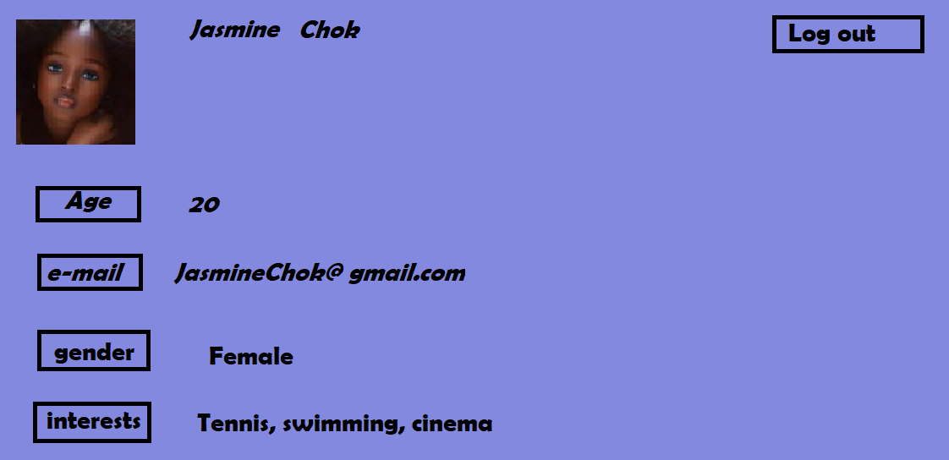

**Clarifications:**

1. Use references to support your report
2. Structure your work based on the template given to you
3. You will have 2 months for your work. During this time you will structure your work step by step.
4. Each portfolio exercise will be uploaded separately at a specific time.
5. Final work will be presented in class during week 14

**Important Note: Please be aware that any suspicion of copying or plagiarism will be fully investigated and punished. No extension will be given. If you face difficulties that are beyond your control, it is your responsibility to contact the course coordinator promptly.**

**When using the template for the report you should bear in mind also the following:**

**The Report should include:**

* Student’s information, Your full name, program title and user identification (e.g. zz009), word count
* Table of contents
* Introduction
* Definition of the case study / problem addressed
* Main Body
* Group synergy
* References
* Header & Footer (include page number)

**References and citation**

Written work should be referenced using the standard University of Bolton referencing style (Harvard Referencing Style)– see:

<https://www.bolton.ac.uk/library/Study-Skills/Referencing/Home.aspx>

**Level HE5** - It is expected that the Reference List will contain between **ten and fifteen sources**. As a MINIMUM the Reference List should include **two refereed academic journals and four academic books**

**Assessment Criteria**

*Relevance 15%*

*Knowledge 20%*

*Argument/Analysis 20%*

*Structure 10 %*

*Presentation 15%*

*Written English 10%*

*Research/Referencing 10%*

***Successful submission:***

*(1) Students submit their report/essay on Turnitin (this is a group project so only one file per team is submitted)*

*(2) if the Similarity report score is acceptable then the report is submitted also on the NYC e-learning platform along with the “Digital Receipt” from Turnitin, otherwise the student has to address any issues and resubmit on* ***Turnitin*** *until the due date.*

*(3) All other files are to be submitted on the e-learning platform*